SIMATS ENGINEERING
ASSESSMENT TOOL 1

COURSE NAME: Operating Systems COURSE CODE: CSA04

COURSE OUTCOME COVERED

CO5: Analyze the components and functionalities of Linux operating systems and virtualization environments to enhance their operational efficiency

Assessment Tool Weightage: 35%

Dr VIMAL V R

QUESTIONS: 5 Total Marks:25

Annexure A

CONSTRAINT BASED PROBLEM SOLVING

Code of Conduct:

I Dhanya Sri M(192572099 (Name / Reg No) certify that this submission is my original work and that I have adhered to the guidelines specified for this assessment.
I understand that any violation of academic integrity rules will result in disciplinary action.

Signature of the student:

Annexure A
CONSTRAINT BASED PROBLEM SOLVING

S.No. | Question | Mark
1 | A server with a total storage capacity of 50 GB needs to effectively manage space for rapidly growing system logs, user files, and application data. Analyze the scenario and design an optimized Linux file system layout, incorporating suitable partitioning techniques and storage management tools (such as log rotation), to ensure efficient utilization of disk space and maintain system stability. The solution must ensure that log files do not exceed 10 GB and that critical services continue to operate without interruption due to disk space exhaustion. | 6
2 | A Linux system handling high CPU workloads suffers from frequent context switching delays. Given that hardware upgrades are not possible and real-time processing must be supported, evaluate kernel-level optimization techniques such as scheduler tuning and the use of kernel modules—to improve overall system performance. | 5
3 | An administrator must process 1 million log entries per day using only shell scripting. Analyze the problem and design an efficient solution using optimized Linux commands that ensures the script completes within 2 minutes. Justify the choice of commands used for achieving high performance | 5
4 | A Linux system runs multiple background services, where a faulty process is consuming 90% of CPU resources. Without restarting the system and while ensuring critical services remain unaffected, analyze the situation and propose a process management strategy using appropriate Linux tools to identify, monitor, and control the faulty process. | 5
5 | A physical server must host 5 virtual machines with a total available RAM of 16 GB. Each VM requires a minimum of 2 GB, while the host operating system needs 4 GB. Analyze the scenario and propose an efficient resource allocation strategy using virtualization concepts to ensure all virtual machines operate smoothly under the given constraints. | 4

RUBRICS FOR CALCULATION

Criteria | Weightage | Level 4 (Exemplary) | Level 3 (Proficient) | Level 2 (Developing) | Level 1 (Beginning)
Problem Understanding | 25% | Clearly defines the problem and identifies all relevant constraints accurately | Identifies most constraints with minor gaps | Partial understanding; misses key constraints | Fails to identify constraints correctly
Constraint Analysis | 25% | Analyzes constraints effectively and prioritizes them logically | Provides reasonable analysis with some prioritization | Limited analysis; weak prioritization | No meaningful analysis or prioritization
Solution Development | 25% | Develops optimal and feasible solutions satisfying all constraints | Develops workable solutions with minor limitations | Solutions partially satisfy constraints | Solutions do not meet constraints
Application of Concepts | 15% | Effectively applies appropriate concepts, methods, or tools | Applies concepts with minor errors | Limited application; requires guidance | Unable to apply relevant concepts
Justification | 10% | Provides strong justification for decisions with logical reasoning | Provides justification with some clarity | Weak or unclear justification | No justification provided

1. Optimized Linux File System Layout for a 50 GB Server
1.1 Introduction
A server has a total storage capacity of 50 GB and is required to store three major types of data:
- Rapidly growing system logs
- User files
- Application data
If all data is stored in a single partition, rapidly growing log files can consume the entire disk. Once the filesystem becomes full, important services may fail because applications cannot create temporary files, write logs, create sockets, or update databases.
Therefore, an optimized Linux filesystem layout should isolate important storage areas and use log rotation, quotas, monitoring, and automatic cleanup.

1.2 Objectives
The filesystem design should:
- Efficiently utilize the 50 GB disk.
- Prevent logs from consuming excessive disk space.
- Ensure logs never exceed 10 GB.
- Protect critical system files from user/application data.
- Provide sufficient space for application data.
- Allow easy monitoring and maintenance.
- Prevent service interruption due to disk exhaustion.

1.3 Proposed Partition Layout
A suitable 50 GB layout is:
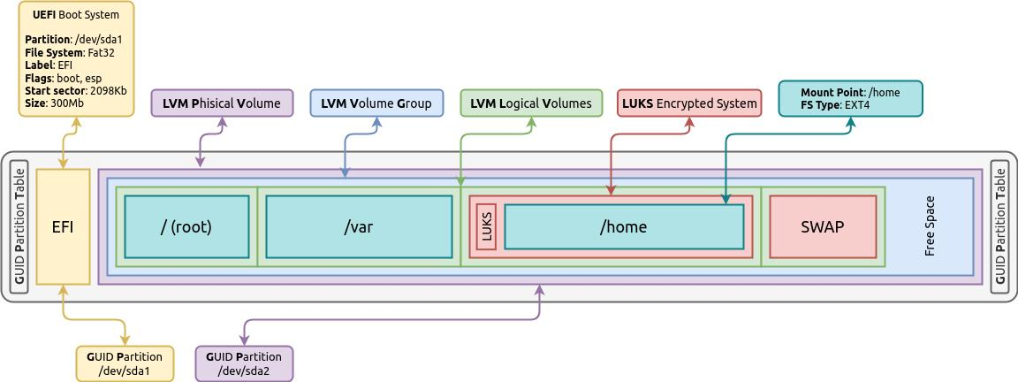
Figure 2. Proposed Linux Disk Partitioning
Partition | Size | Purpose
/boot | 1 GB | Kernel and boot files
/ | 10 GB | Operating system
/home | 10 GB | User files
/var | 10 GB | Logs, cache and variable data
/opt | 12 GB | Application data
Swap | 4 GB | Virtual memory
Reserved/free space | 3 GB | Emergency/maintenance space
Total | 50 GB
The /var partition is deliberately limited to 10 GB, because /var/log contains system and application logs.
However, simply creating a 10 GB /var partition does not by itself guarantee that logs remain below 10 GB. Log rotation must also be configured.

1.4 Filesystem Structure
A possible structure is:
/
├── boot
├── etc
├── usr
├── bin
├── sbin
├── home
│ ├── user1
│ └── user2
├── var
│ ├── log
│ ├── cache
│ └── spool
└── opt
├── application1
└── application2
The important idea is to separate frequently changing data from the operating system.

1.5 Why Separate /var?
Linux stores many dynamic files under /var, including:
- System logs
- Package cache
- Mail queues
- Application logs
- Temporary variable data 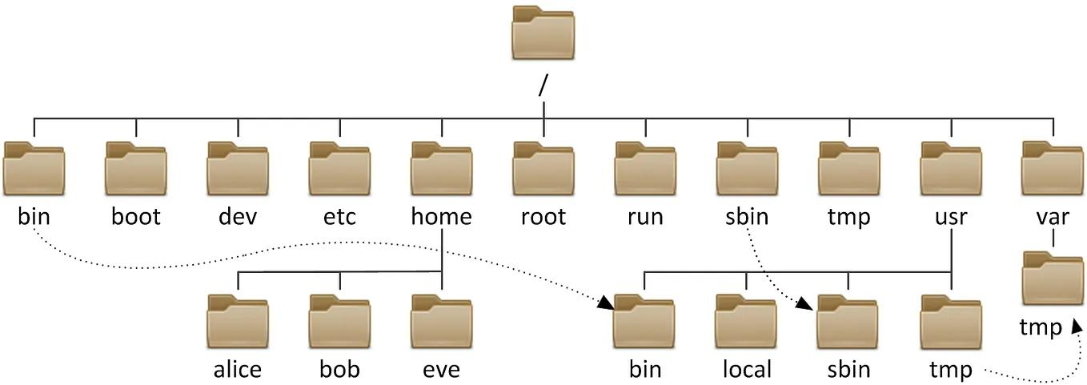
Figure 1. Linux File System Hierarchy
If /var is part of /, excessive logging can consume the root filesystem.
For example:
Root filesystem = 10 GB
Application log = 15 GB
The log could consume the entire root filesystem, potentially causing:
No space left on device
Separating /var protects the root filesystem.

1.6 Log Rotation
Linux provides the logrotate utility for automatically managing logs.
A logrotate policy can:
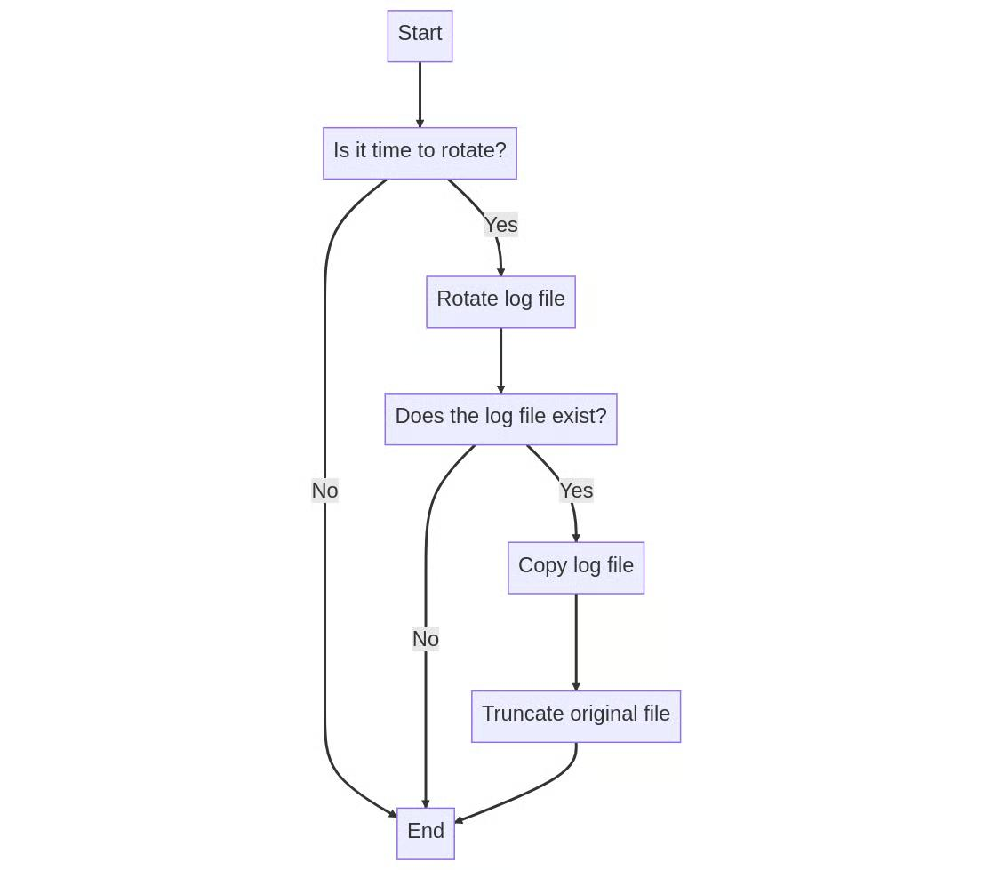
Figure 3. Automatic Log Rotation and Compression
- Rotate old logs.
- Compress old logs.
- Delete old logs.
- Keep a fixed number of historical logs.
- Prevent a single log from growing indefinitely.
Example configuration:
/var/log/myapp/*.log {
daily
rotate 7
compress
delaycompress
missingok
notifempty
size 500M
copytruncate
}
This means logs are rotated regularly and older logs are compressed.

1.7 Keeping Logs Below 10 GB
The /var partition is 10 GB, but a better design is to reserve only a portion for logs.
For example:
/var = 10 GB

/var/log = approximately 7–8 GB usable
Other /var data = approximately 2–3 GB
Logrotate can maintain a controlled number of historical files.
Example:
Current log = 500 MB
Rotated log 1 = 500 MB
Rotated log 2 = 500 MB
...
With compression, older logs require considerably less storage.
A monitoring script can also check:
du -sh /var/log
and:
df -h /var

1.8 Disk Quotas
User files can also consume disk space. Linux filesystem quotas can restrict individual users.
For example:
quota
and:
repquota /home
can be used to inspect quota usage.
This prevents one user from consuming the entire /home filesystem.

1.9 Disk Usage Monitoring
The administrator should regularly monitor:
Check filesystem usage
df -h
Check directory usage
du -sh /var/log/*
Find large files
find /var/log -type f -size +500M -ls
Check inode usage
df -i
Inode exhaustion can also prevent files from being created even when free disk space remains.

1.10 Preventing Service Failure
The server should have monitoring thresholds.
For example:
< 70% Normal
70–80% Warning
80–90% Critical
> 90% Emergency cleanup
A monitoring script can alert the administrator:
USAGE=$(df /var --output=pcent | tail -1 | tr -d ' %')

if [ "$USAGE" -ge 90 ]; then
echo "Critical: /var filesystem is almost full"
fi

1.11 Storage Management Tools
Useful Linux tools include:
Tool | Purpose
df | Filesystem free-space monitoring
du | Directory/file space analysis
find | Find large or old files
logrotate | Automatic log rotation
gzip | Compress old logs
quota | Limit user storage
journalctl | Manage systemd journal logs
systemctl | Manage services
lsblk | Display block devices
fdisk/parted | Partition management

1.12 Conclusion
The best strategy is to separate /, /home, /var, and /opt so that rapidly growing logs and application data cannot consume the entire operating system partition. A 10 GB /var partition combined with logrotate, compression, quotas, disk monitoring, and emergency alerts ensures that log growth is controlled and critical services continue operating.
Result: The 50 GB storage is efficiently divided, logs are kept within the required limit, and disk exhaustion is prevented from causing service interruption.

___________________________________________________________________________

2. Kernel-Level Optimization for High CPU Workloads and Context Switching
2.1 Introduction
Context switching occurs when the CPU switches from one process or thread to another.
In a high CPU workload, excessive context switching can cause:
- CPU overhead
- Cache misses
- Scheduling delays
- Reduced throughput
- Poor real-time responsiveness
Since hardware upgrades are not possible, the solution must focus on kernel and scheduler optimization.

2.2 Problem Analysis
Suppose a system has many CPU-intensive processes:
Process A → CPU
Process B → CPU
Process C → CPU
Process D → CPU
Process E → CPU
The scheduler repeatedly switches between them.
If the switching frequency is unnecessarily high:
Useful computation ↓
Scheduling overhead ↑
Cache efficiency ↓
Performance ↓
Therefore, scheduler behavior should be tuned according to workload.
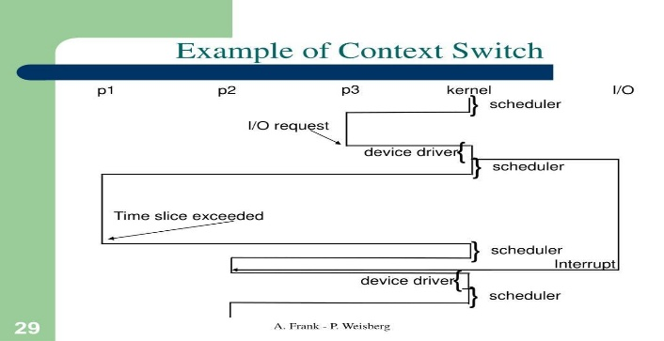
Figure 1. Context Switching Between Processes

2.3 Linux Scheduler
Modern Linux systems use the kernel scheduler to determine which runnable task gets CPU time.
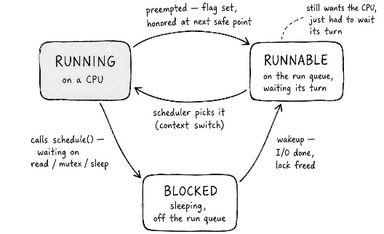
Figure 2. Linux CPU Scheduling
Important concepts include:
- Scheduling priority
- CPU affinity
- Nice values
- Real-time scheduling
- CFS behavior
- CPU isolation
- Interrupt handling

2.4 Adjust Process Priority
The nice and renice commands can change process scheduling priority.
Start a process with a different nice value:
nice -n 10 ./application
Change an existing process:
renice -n 10 -p PID
For real-time workloads, Linux also provides real-time scheduling policies such as:
chrt
Example:
chrt -f 50 ./realtime_app
Real-time priorities should be used carefully because a badly configured real-time process can prevent other processes from receiving CPU time.

2.5 CPU Affinity
CPU affinity allows a process to run only on selected CPU cores.
Command:
taskset -cp 0,1 PID
This can reduce unnecessary migration of processes between CPUs.
For example:
Without affinity: 

Process → CPU0 → CPU2 → CPU1 → CPU3

With affinity:

Process → CPU0
This can improve cache locality.

2.6 Scheduler Tuning
Linux scheduler behavior can be examined using:
sysctl -a | grep sched
Kernel parameters should be modified cautiously and tested against the specific workload.
For real-time workloads, the administrator may consider a PREEMPT_RT-capable kernel, where appropriate, because it reduces scheduling latency and improves deterministic response.

2.7 Kernel Modules
Kernel modules allow functionality to be added to the kernel without rebuilding the entire kernel.
Useful commands include:
lsmod
to list loaded modules.
Load a module:
modprobe module_name
Remove a module:
modprobe -r module_name
Information about a module:
modinfo module_name

2.8 How Kernel Modules Help
Kernel modules can improve performance when they provide:
- Optimized device drivers
- Hardware-specific functionality
- Efficient networking support
- Specialized filesystem support
However, unnecessary modules should not be blindly removed. Modules should be changed only after confirming that they are not required by the system.

2.9 Interrupt Optimization
High CPU workloads may also involve excessive hardware interrupts.
The administrator can inspect interrupt activity:
cat /proc/interrupts
For multiprocessor systems, interrupt balancing can help distribute interrupt processing.
The tool:
irqbalance
can distribute hardware interrupts across CPUs where appropriate.

2.10 Monitoring Context Switches
The administrator can use:
vmstat 1
Important columns include:
cs
which represents context switches.
Another useful tool is:
pidstat -w 1
This provides process-level context-switch information.

2.11 Optimization Strategy
A practical strategy is:
Identify workload
↓
Measure context switching
↓
Identify CPU-heavy processes
↓
Tune process priority
↓
Set CPU affinity
↓
Optimize interrupt distribution
↓
Evaluate scheduler configuration
↓
Test real-time behavior
↓
Monitor again

2.12 Precautions
Scheduler tuning should not be performed blindly.
Before modification:
vmstat 1
pidstat -w 1
top
should be used to establish a baseline.
After modification, compare:
- CPU utilization
- Context switches
- Response latency
- Throughput
- Task completion time

2.13 Conclusion
Because hardware upgrades are unavailable, performance can be improved using scheduler tuning, CPU affinity, priority management, real-time scheduling policies, interrupt balancing, and carefully selected kernel modules.
The most important principle is to measure first and tune second.
Result: Reduced unnecessary context switching, improved CPU cache locality, lower scheduling overhead, and better real-time responsiveness can be achieved without changing the hardware.

___________________________________________________________________________

3. Processing 1 Million Log Entries Per Day Using Shell Scripting
3.1 Introduction
Processing 1 million log entries per day using only shell scripting can become slow if inefficient commands and repeated loops are used.
The main requirement is:
The processing must finish within 2 minutes.
Therefore, the solution should minimize:
- Process creation
- Disk I/O
- Repeated command execution
- Unnecessary pipelines
- Shell-level loops

3.2 Inefficient Approach
A common but inefficient approach is:
while read line
do
grep ...
awk ...
echo ...
done < logfile
If one or more external commands are executed for every line, the script can create thousands or millions of processes.
For example:
1,000,000 lines
× multiple external commands
= huge process overhead
This may violate the two-minute requirement.

3.3 Optimized Approach
Use tools capable of processing the entire file in a single invocation.
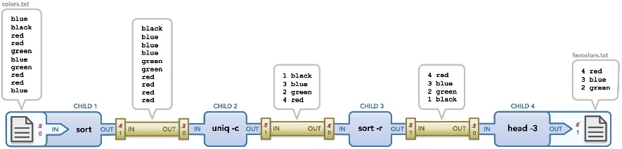
Figure 1. Optimized Linux Log Processing Pipeline
The most important tools are:
- awk
- grep
- sort
- uniq
- cut
- sed
Among these, awk is especially suitable because it can read and process records in a single pass.

3.4 Example Log
Suppose the log contains:
2026-08-31 10:00:01 INFO UserLogin
2026-08-31 10:00:02 ERROR DatabaseFailure
2026-08-31 10:00:03 INFO FileAccess
2026-08-31 10:00:04 ERROR NetworkFailure
The objective may be to count errors.

3.5 Efficient AWK Processing
Instead of repeatedly calling commands:
awk '$3 == "ERROR" {count++} END {print count}' logfile
The entire file is processed in one awk execution.
For example:
awk '
$3 == "ERROR" { errors++ }
$3 == "INFO" { info++ }
END {
print "ERROR:", errors
print "INFO:", info
}' logfile
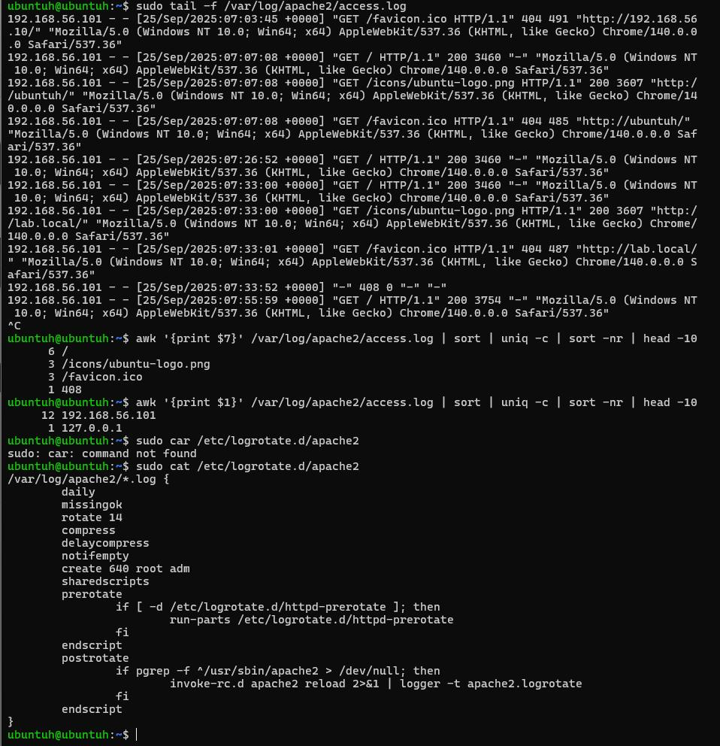

3.6 Avoid Unnecessary Cat
Avoid:
cat logfile | awk ...
Use:
awk '...' logfile
The second method avoids an unnecessary process.
Similarly, instead of:
cat logfile | grep ERROR
use:
grep ERROR logfile

3.7 Efficient Filtering
For simple text matching:
grep -F "ERROR" logfile
grep -F performs fixed-string matching and avoids regular-expression processing when regex is unnecessary.
For multiple patterns:
grep -E 'ERROR|CRITICAL' logfile

3.8 Counting Log Entries
Example:
grep -cF "ERROR" logfile
This directly counts matching lines.
For more complicated processing:
awk '/ERROR/ {count++} END {print count}' logfile

3.9 Sorting and Counting
If log processing requires frequency analysis:
awk '{print $3}' logfile | sort | uniq -c
This can identify the frequency of log levels.
For very large files, sorting can be expensive because sorting generally requires additional CPU and memory/disk activity.
Therefore, if possible, counting should be performed directly in awk.
Example:
awk '
{
count[$3]++
}
END {
for (x in count)
print x, count[x]
}' logfile
This avoids a full sort.

3.10 Parallel Processing
If the system has multiple CPU cores and the log can safely be divided into independent chunks, parallel processing may improve performance.
For example, tools such as:
split
can divide a large file into chunks.
However, blindly splitting a log can create complications if records span boundaries or if processing requires global ordering.
Therefore, single-pass awk should be preferred first, and parallelism should be introduced only if profiling shows it is necessary.

3.11 Measuring Execution Time
Use:
time ./process_logs.sh
Example:
real 0m48.2s
user 0m42.1s
sys 0m5.8s
The important value for the two-minute requirement is the elapsed real time.

3.12 Optimized Script Example
#!/bin/bash

LOGFILE="server.log"

awk '
{
total++

if ($3 == "ERROR")
errors++
else if ($3 == "WARNING")
warnings++
else if ($3 == "INFO")
info++
}
END {
print "Total Entries :", total
print "ERROR :", errors
print "WARNING :", warnings
print "INFO :", info
}' "$LOGFILE"
This uses one major processing command and avoids launching an external process for each record.

3.13 Performance Techniques
Technique | Benefit
Single-pass awk | Processes file efficiently
Avoid shell loops | Reduces interpreter overhead
Avoid cat | Reduces unnecessary process
grep -F | Efficient fixed-string search
Avoid unnecessary sort | Reduces CPU/I/O
Buffered processing | Reduces disk operations
Process chunks only when useful | Enables parallelism
time | Measures performance

3.14 Meeting the 2-Minute Requirement
The processing pipeline should be tested using the actual 1-million-entry workload.
For example:
time ./process_logs.sh
If execution exceeds 120 seconds:
- Remove unnecessary pipelines.
- Replace shell loops with awk.
- Reduce repeated commands.
- Avoid unnecessary sorting.
- Reduce disk writes.
- Consider chunked parallel processing if the workload is independent.

3.15 Conclusion
For processing one million log entries within two minutes, the most important optimization is to avoid per-line shell command execution. A single-pass awk program can process the complete log efficiently with substantially less process-creation overhead.
Result: Using optimized commands such as awk, grep -F, and carefully selected sort/uniq operations, together with benchmarking through time, provides a practical shell-only solution for high-volume log processing.

__________________________________________________________________________

4. Managing a Faulty Process Consuming 90% CPU
4.1 Introduction
A Linux server is running several background services, but one faulty process is consuming approximately 90% of CPU resources.
The administrator must:
- Identify the process.
- Monitor it.
- Reduce its CPU consumption.
- Ensure critical services remain unaffected.
- Avoid rebooting the server.
Linux provides several process-management utilities for this purpose.

4.2 Step 1: Identify the CPU-Consuming Process
Use:
top
or:
htop
In top, press:
P
to sort processes by CPU usage.
Example:
PID USER %CPU COMMAND
2456 user 90.0 faulty_app
1020 root 5.0 critical_service
Here, PID 2456 is consuming excessive CPU.

4.3 Step 2: Examine the Process
Use:
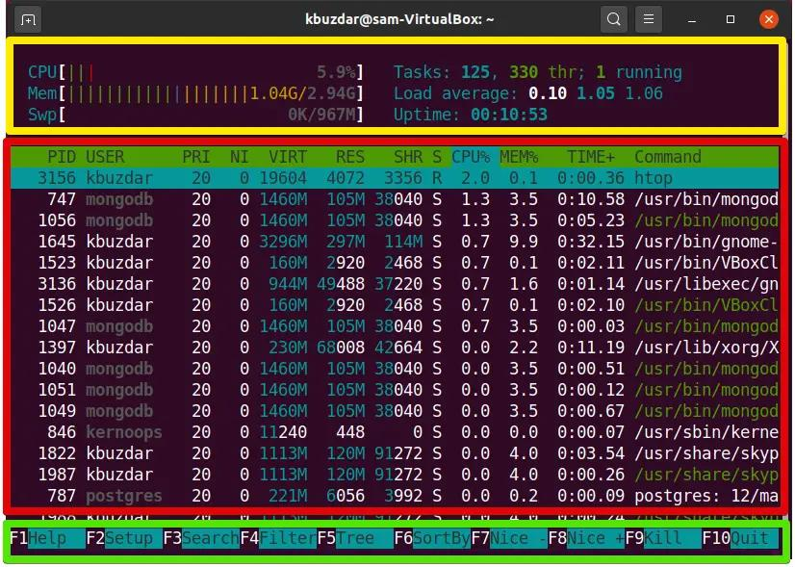
ps -p 2456 -f
This provides information such as:
- PID
- Parent PID
- User
- Start time
- Command
More detailed information:
ps -o pid,ppid,user,%cpu,%mem,stat,etime,cmd -p 2456

4.4 Step 3: Determine Whether It Is Critical
Before terminating a process, identify:
systemctl status service_name
Also check the process tree:
pstree -p 2456
This helps determine whether the process is a standalone application or part of a critical service.

4.5 Step 4: Monitor the Process
Use:
top -p 2456
or:
pidstat -p 2456 1
This allows the administrator to observe whether CPU consumption remains high.

4.6 Step 5: Reduce CPU Priority
If the process is not immediately dangerous but should not dominate the CPU:
renice +10 -p 2456
A higher nice value generally gives the process lower scheduling priority.
This allows critical services to receive CPU time.

4.7 CPU Affinity
The faulty process can be restricted to particular CPU cores.
For example:
taskset -cp 0 2456
This limits the process to CPU core 0.
If critical services use other cores, this can reduce interference.
However, CPU affinity must be selected according to the actual system topology and workload.

4.8 Step 6: Graceful Termination
If the process is confirmed to be faulty and can be stopped safely:
kill 2456
This sends the default SIGTERM, allowing the application an opportunity to terminate cleanly.
Check whether it stopped:
ps -p 2456
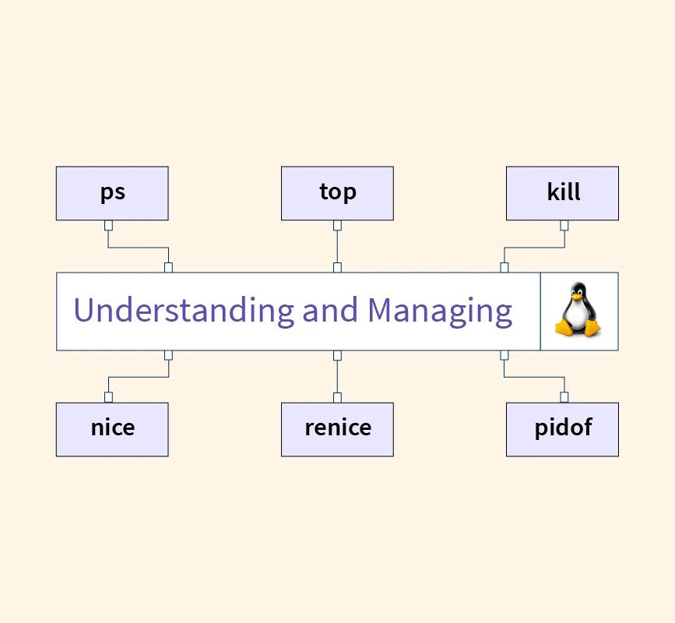

4.9 Forceful Termination
If the process does not respond:
kill -9 2456
SIGKILL should be the last resort, because the process cannot perform normal cleanup.

4.10 If It Is a Service
If the faulty process belongs to a systemd service, manage the service rather than manually killing individual processes.
Check:
systemctl status myservice
Stop:
systemctl stop myservice
Restart:
systemctl restart myservice
This is safer because systemd understands the service's process hierarchy and configuration.

4.11 Prevent Automatic Restart
If the faulty service immediately restarts and causes another CPU spike, inspect its systemd configuration and restart policy.
For example:
systemctl cat myservice
Look for:
Restart=
An administrator may temporarily adjust the service configuration if appropriate, but this should be done carefully because automatic restart may be required for service availability.

4.12 Monitor Critical Services
After controlling the faulty process, verify:
systemctl --failed
and:
systemctl status critical_service
CPU usage can be monitored with:
top
or:
vmstat 1

4.13 Process Management Strategy
The complete strategy is:
Identify high CPU process
↓
Check PID and command
↓
Determine whether process is critical
↓
Monitor CPU usage
↓
Lower priority if possible
↓
Restrict CPU affinity if appropriate
↓
Gracefully terminate if necessary
↓
Force kill only as last resort
↓
Check critical services
↓
Monitor system stability

4.14 Important Precautions
The administrator should not immediately execute kill -9.
A better approach is:
Observe → Analyze → Limit → Gracefully stop → Force kill if necessary
This reduces the risk of data corruption or service interruption.

4.15 Conclusion
Linux provides powerful process-management tools such as top, htop, ps, pidstat, renice, taskset, kill, systemctl, and pstree.
The recommended strategy is to first identify and analyze the faulty process, then reduce its impact using priority or CPU affinity. If the process remains faulty, it should be gracefully terminated and only forcefully killed as a last resort.
Result: The 90% CPU-consuming process can be controlled without rebooting the server, while critical services remain operational.

___________________________________________________________________________

5. RAM Allocation for 5 Virtual Machines on a 16 GB Server
5.1 Introduction
A physical server has:
- Total RAM = 16 GB
- Number of VMs = 5
- Minimum RAM required per VM = 2 GB
- Host OS requirement = 4 GB
The objective is to allocate memory efficiently while ensuring all VMs and the host operate smoothly.

5.2 Calculate the Minimum Requirement
Each VM requires at least:
2 GB
For five VMs:
5 × 2 GB = 10 GB
Host requirement:
4 GB
Total:
10 GB + 4 GB = 14 GB
Available:
16 GB
Remaining:
16 − 14 = 2 GB
Therefore, the server has 2 GB of additional memory available after meeting all minimum requirements.

5.3 Basic Allocation
The minimum allocation is:
Component | RAM
Host OS | 4 GB
VM1 | 2 GB
VM2 | 2 GB
VM3 | 2 GB
VM4 | 2 GB
VM5 | 2 GB
Unallocated buffer | 2 GB
Total | 16 GB
This satisfies all minimum requirements.

5.4 Recommended Allocation
A better strategy is not to immediately assign all available memory to the VMs.
Recommended:
Host OS = 4 GB
VM1 = 2 GB
VM2 = 2 GB
VM3 = 2 GB
VM4 = 2 GB
VM5 = 2 GB
Reserve = 2 GB
The 2 GB reserve can accommodate:
- Host memory fluctuations
- Hypervisor overhead
- Temporary workloads
- Memory pressure
- Caching

5.5 Why Keep a Reserve?
If all 16 GB were allocated directly:
Host = 4 GB
VMs = 12 GB
There would be no free headroom.
This is risky because virtualization itself requires resources, and the host may require additional memory.
A memory reserve improves system stability.

5.6 Dynamic Memory Allocation
If supported by the virtualization platform, memory can be dynamically adjusted.
For example:
VM1 → 2 GB
VM2 → 2 GB
VM3 → 2 GB
VM4 → 2 GB
VM5 → 2 GB
If VM3 temporarily requires additional memory, available memory can be assigned to it while maintaining sufficient host memory.
This is more efficient than permanently allocating large amounts of memory to every VM.

5.7 Ballooning
Memory ballooning is a virtualization technique that allows a guest VM to return memory to the hypervisor when it is not needed.
Example:
VM1 requires 2 GB → allocated 2 GB
VM2 temporarily idle → releases some memory
VM3 requires additional memory → receives available memory
This improves overall memory utilization.

5.8 Memory Overcommit
Memory overcommit means that the virtualization layer can provision more virtual memory than the physical RAM available.
For example:
Physical RAM = 16 GB
Virtual RAM assigned = >16 GB
However, overcommitment should be avoided or kept conservative in this scenario, because each VM already has a stated minimum requirement and real-time memory pressure could degrade performance.

5.9 Swap
The host should have suitable swap configured, but swap should not be treated as a replacement for required physical RAM.
If the host begins heavily swapping:
RAM → full
↓
Swap → active
↓
Disk I/O ↑
↓
VM performance ↓
Therefore, sufficient physical memory should be maintained for the host and VMs.

5.10 CPU and Memory Monitoring
The administrator should continuously monitor the virtualization host.
Useful Linux tools include:
free -h
top
vmstat 1
For KVM/libvirt environments:
virsh dominfo VM_NAME
and:
virsh dommemstat VM_NAME
These help determine whether a VM is actually using its allocated memory.

5.11 Resource Allocation Diagram
Physical Server
16 GB RAM
|
+--------------+--------------+
| |
Host OS VM Resources
4 GB 10 GB
|
+--------------------+------------------+
| | | | |
VM1 VM2 VM3 VM4 VM5
2 GB 2 GB 2 GB 2 GB 2 GB

Remaining Reserve = 2 GB

5.12 Priority-Based Allocation
If the VMs have different workloads, the administrator can allocate the reserve according to demand.
For example:
VM | Minimum | Possible Allocation
VM1 | 2 GB | 2 GB
VM2 | 2 GB | 2 GB
VM3 | 2 GB | 3 GB
VM4 | 2 GB | 2 GB
VM5 | 2 GB | 3 GB
Host | 4 GB | 4 GB
This totals:
2 + 2 + 3 + 2 + 3 + 4 = 16 GB
However, this should only be done if VM3 and VM5 genuinely need the additional memory and the host has enough operational headroom.
For a conservative configuration, keeping 2 GB as a reserve is safer.

5.13 Best Virtualization Strategy
The recommended approach is:
Step 1
Reserve:
4 GB → Host OS
Step 2
Allocate:
2 GB → each VM
Step 3
Keep:
2 GB → reserve
Step 4
Monitor actual memory utilization.
Step 5
Dynamically increase memory for VMs that require it, if supported.
Step 6
Avoid aggressive memory overcommitment.

5.14 Advantages
This strategy provides:
- Guaranteed minimum memory for every VM
- Stable host operation
- Memory headroom
- Better resource utilization
- Reduced swapping
- Ability to respond to changing workloads
- Improved VM performance

5.15 Conclusion
The server has enough RAM to satisfy the minimum requirements:
5 VMs × 2 GB = 10 GB
Host = 4 GB
Total = 14 GB
This leaves 2 GB of RAM.
The most efficient and safe allocation is therefore:
Host OS = 4 GB
VM1 = 2 GB
VM2 = 2 GB
VM3 = 2 GB
VM4 = 2 GB
VM5 = 2 GB
Reserve = 2 GB
--------------------------------
Total = 16 GB
Dynamic memory techniques such as ballooning, together with continuous monitoring, can further improve utilization.
Result: All five virtual machines receive their required minimum 2 GB, the host receives its required 4 GB, and a 2 GB reserve provides additional stability under changing workloads.

